**DAEMON Eurorack Module Through-hole assembly document**

**Rear of PCB:**

1) Solder power header. Masking tape can help hold it in place while you solder on the other side.

Top view before soldering

2) 10uF capacitors

**Top of PCB:**

3) Reverse connection protection diodes

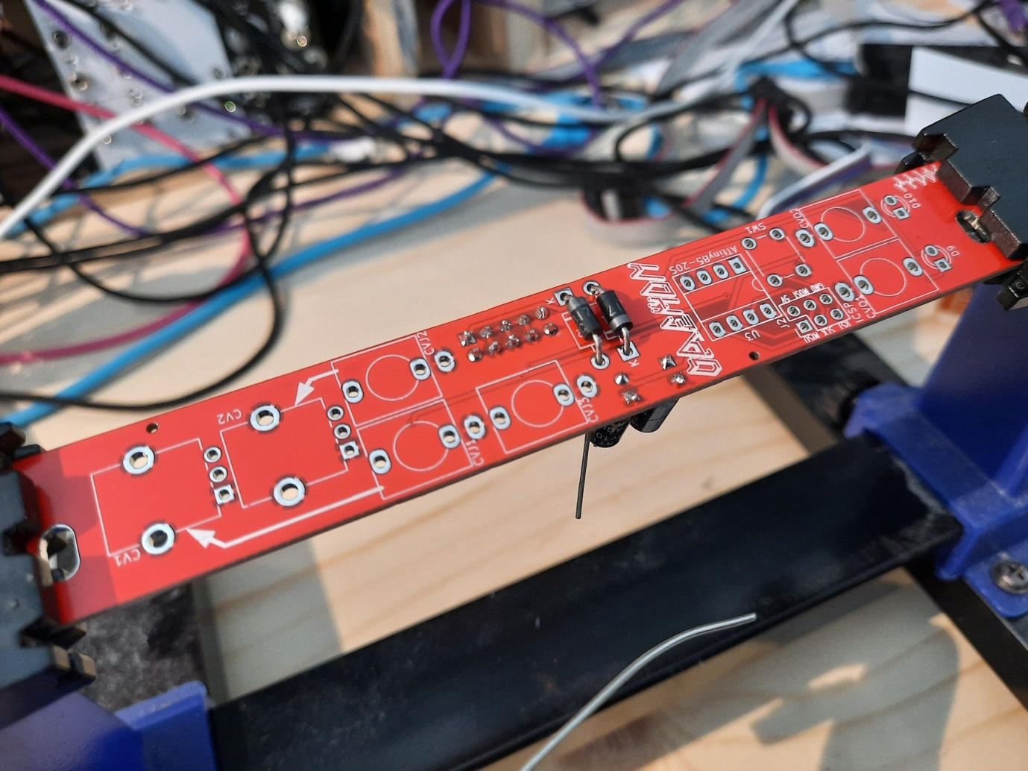

4) 6mm button and IC socket. Take care to point the indent on the socket the same way as the mark on the silkscreen.

5) ISP socket. Use masking tape to hold it in place as you solder.

6) Thonkiconn 3.5mm mono jacks

7) Knobs. Depending on the PCB version, these are short B100k 9mm trimpots or 9mm Alpha pots with T18 shafts.

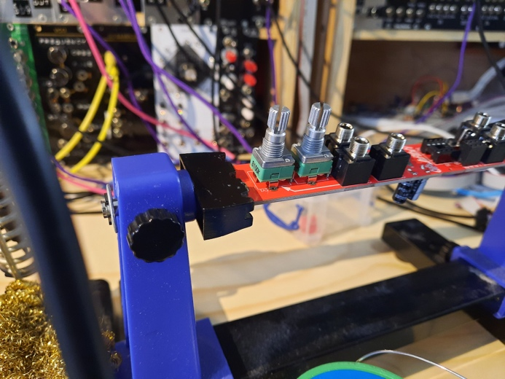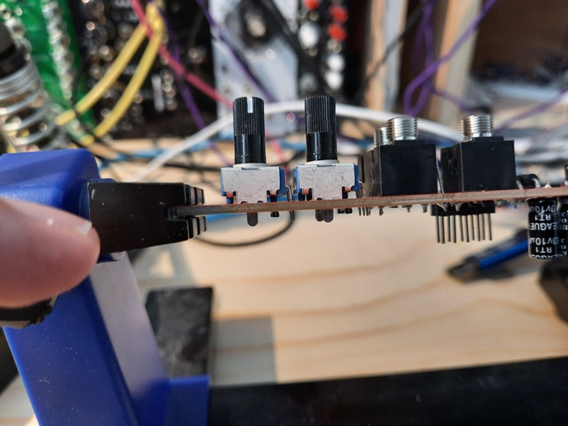

Rear view of the soldered knobs:

8) LEDs. The flat side of the LED should be over the square pad. Red and blue are supplied with the kit, but any colour will work.

9) If your kit has knobs with metal shafts, fit the knob caps now. Turn the knobs all the way to the left and slide the caps on with the metal dot pointing to about 7 o'clock.A picture containing person, indoor
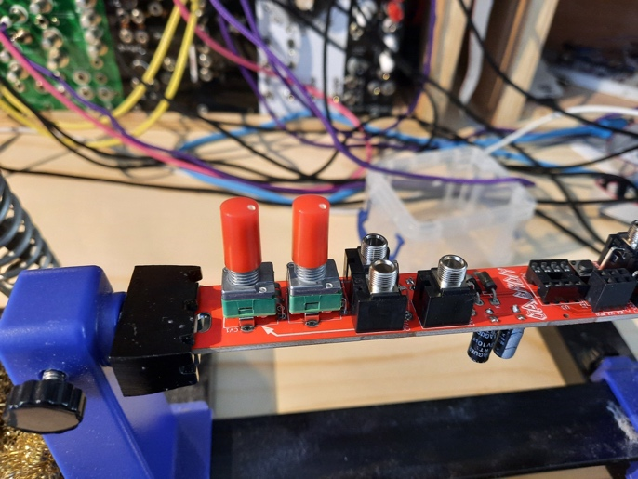

10) Finally, insert the ATTiny microcontroller into the IC socket, with the semi-circular indent facing the one on the socket, and the semi-circular mark on the silkscreen.

That's the end of the build process. The microcontroller comes with some pre-installed firmware, but please check out my github repo for more firmware and instructions showing you how to upload it: https://github.com/Blinken-Lights/ASCII

And please, if you write your own firmware for this module, please let me know how you get on, and what you make with it. I'd love it if people started hacking and remixing this module. My aim was to make the most bare bones platform for a microcontroller without tying the module down to having any particular function.